File permissions in Linux

Project description
This activity represents the process of changing files and folders permission in the linux operation system. This is done to achieve the principle of least privilege security measure. This activity demonstrates listing the files, directories and hidden files along with their permissions, and changing their permissions using the chmod command.

Check file and directory details
We can list all the files and folders using the ls command.
To list them with permission we can couple it with -l options: ls -l
To include hidden files as well, we can use the -la options: ls -la

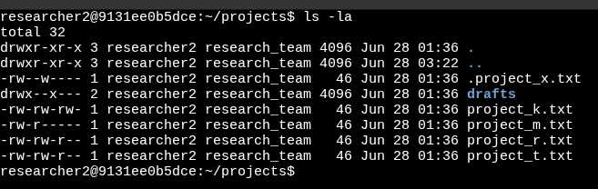

Describe the permissions string
The project_t.txt has the following permissions -rw-rw-r--
The 1st character, the hyphen - represents it as a file.
The 2nd, 3rd and 4th characters rw- represent the user permissions. The user has read and write permission.
- r = can read
- w = can write
- - = cannot execute
The 5th, 6th and 7th characters rw- represent the group permissions. This represents the permission for all the users of that group. The group has read and write permission.
- r = can read
- w = can write
- - = cannot execute
The 8th, 9th and 10th characters r-- represent the others permissions. This represents all the other users. The group has read permission only.
- r = can read
- - = cannot write
- - = cannot execute

Change file permissions
We can change the file permission using the chmod command. The symbolic mode is an easier way to change the command. The following command describes how to change it:
chmod g-w,o-r project_t.txt
Here, the command chmod is followed by g-w,o-r. This can be decoded as follows:
- g = group
- - = remove
- w = write permission
- , = divider
- o = others
- - = remove
- r = read permission
We are removing the write permission from the group, and we are removing the read permission from others.

Change file permissions on a hidden file
We can list the files and directories along with hidden files using the following command:
ls -la
The file with the . at the beginning represents the hidden file. Here, it is the .project_x.txt.
We can change the file permission using the chmod command. The following command describes how to change it:
chmod g-w .project_x.txt
Here, the command chmod is followed by g-w. This can be decoded as follows:
- g = group
- - = remove
- w = write permission
We are removing the write permission from the group.

Change directory permissions
The directory has the d character at the beginning. Here, it is the drafts folder.
We can change the file permission using the chmod command. The following command describes how to change it:
chmod g-x drafts
Here, the command chmod is followed by g-w. This can be decoded as follows:
- g = group
- - = remove
- x = execute permission
We are removing the execute permission from the group. Making it inaccessible for the group.

Summary
The above demonstrations listed the files, directories, and hidden files within the projects folder, changed the permission of the file project_t.txt, changed the permission of the hidden file .project_x.txt, and changed the permission of the directory drafts.

